**SQL Queries:**

4

/*List count of total number of unique employees tracked in EmployeePayHistorySCD? */

select count(distinct(EmployeeID)) as No_Unique_Emp

from EmployeePayHistorySCD

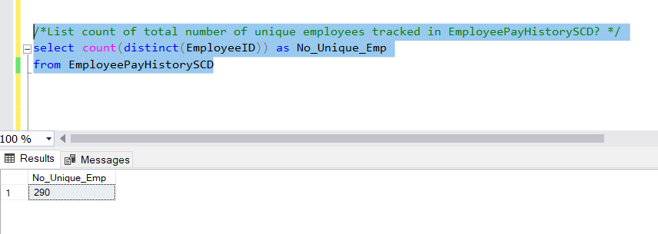

5.

/*What employee had the most pay changes? */

select EmployeeID,Emp_Name,total_change

from

(select EmployeeID,concat(FirstName,' ',MiddleName,' ',LastName) as Emp_Name,count(EmployeeID) as total_change,

DENSE_RANK() over (order by count(EmployeeID) desc) as rnk

from EmployeePayHistorySCD

group by EmployeeID,FirstName,MiddleName,LastName

)base

where base.rnk=1

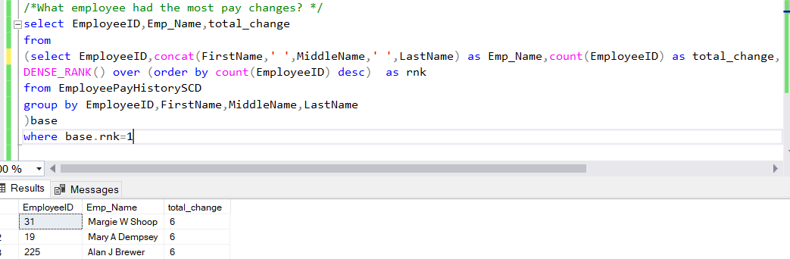

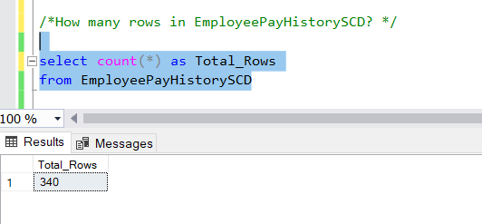

6. /*How many rows in EmployeePayHistorySCD? */

select count(*) as Total_Rows

from EmployeePayHistorySCD

7.

/*What was the employee(s) with the first pay rate recorded?*/

select EmployeeID,Emp_Name,rate

from

(select EmployeeID,concat(FirstName,' ',MiddleName,' ',LastName) as Emp_Name,rate,min ([scd_effective_date])

as min_date,

DENSE_RANK() over (order by min ([scd_effective_date]) asc) as rnk

from EmployeePayHistorySCD

group by EmployeeID,FirstName,MiddleName,LastName,rate

)base

where base.rnk=1

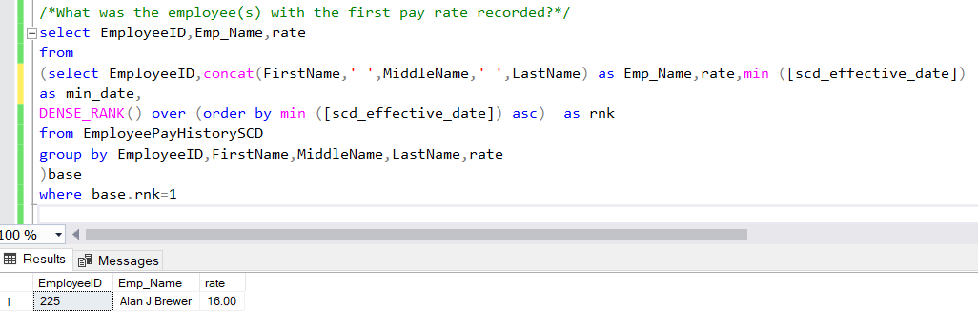

8

/*What was the employee(s) with the last recorder pay rate recorded?*/

select EmployeeID,Emp_Name,rate

from

(select EmployeeID,concat(FirstName,' ',MiddleName,' ',LastName) as Emp_Name,rate,

max ([scd_effective_date]) as min_date,

DENSE_RANK() over (order by max ([scd_effective_date]) asc) as rnk

from EmployeePayHistorySCD

group by EmployeeID,FirstName,MiddleName,LastName,rate

)base

where base.rnk=1

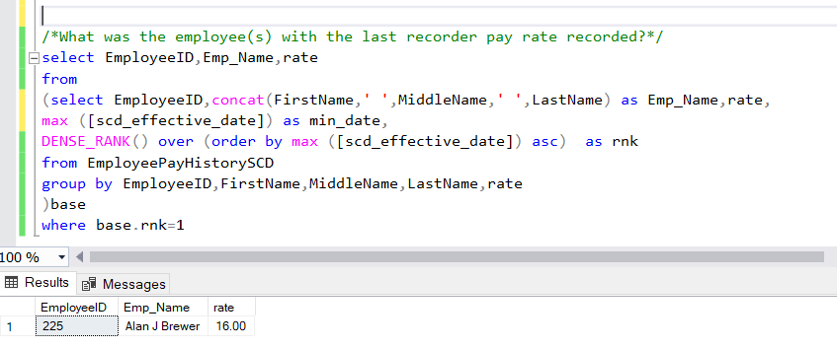

/*total number of pay increases including original pay*/

select EmployeeID,concat(FirstName,' ',MiddleName,' ',LastName) as Emp_Name, count(EmployeeID) as Total_Change

from EmployeePayHistorySCD

group by EmployeeID,FirstName,MiddleName,LastName

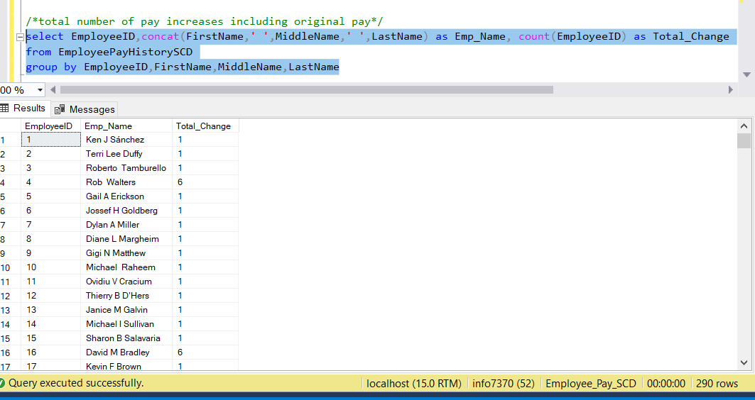

/*a detailed listing employee, pay and scd start and scd end date*/

select EmployeeID,concat(FirstName,' ',MiddleName,' ',LastName) as Emp_Name,[Rate]

,[scd_effective_date]

,[scd_ineffective_date]

from EmployeePayHistorySCD

